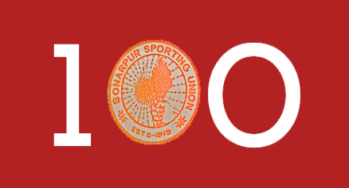**Sonarpur Sporting Union**

**Celebrating 100 Years.**